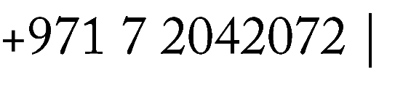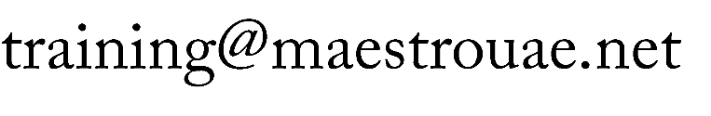

**COMPENSATION, BENEFITS & EMPLOYEE RELATIONS**

**COURSE OUTLINE 2026**

**TRAINING TITLE**

COMPENSATION, BENEFITS & EMPLOYEE RELATIONS

**VENUE**

DUBAI, UAE

**DURATION**

5 Days

**DATES**

09-13 February 2026

**PRICE**

$5,250 per attendee including training material/handouts, morning/afternoon coffee breaks and Lunch.

**TRAINING INTRODUCTION**

The **Compensation, Benefits & Employee Relations** course provides HR professionals and managers with the essential knowledge and practical skills to design competitive compensation structures, manage employee benefits programs, and foster strong employee relations. The course covers legal frameworks, strategic planning, employee engagement, and conflict resolution techniques. Participants will learn how to align compensation and benefits with business goals while maintaining fairness, compliance, and a motivated workforce.

**TRAINING OBJECTIVES**

By the end of the course, participants will be able to:

* Understand the components and objectives of a total compensation strategy.
* Design and implement effective salary structures and incentive programs.
* Manage employee benefits in a cost-effective and competitive manner.
* Interpret and apply labor laws and regulations related to pay and employee rights.
* Foster positive employee relations and handle grievances effectively.
* Support organizational goals through employee engagement and retention strategies.
* Conduct job evaluations and market benchmarking.

**TRAINING AUDIENCE**

* HR Managers and Officers
* Compensation and Benefits Specialists
* Employee Relations Managers
* Payroll Administrators
* Line Managers and Team Leaders
* Business Owners and Entrepreneurs
* Anyone involved in HR planning or people management

**TRAINING OUTLINE**

#### **Day 1: Introduction to Compensation and Benefits**

* **Module 1: Fundamentals of Total Rewards**
  + What is total compensation?
  + Direct vs. indirect compensation
  + Strategic role of compensation and benefits
* **Module 2: Job Analysis and Evaluation**
  + Conducting job analysis for pay decisions
  + Job grading and classification systems
  + Internal equity and pay structure development

#### **Day 2: Compensation Planning and Salary Structures**

* **Module 3: Developing Pay Structures**
  + Building salary ranges and pay scales
  + Pay for performance vs. fixed pay
  + Market pricing and benchmarking techniques
* **Module 4: Incentives and Variable Pay**
  + Bonuses, commissions, and incentive pay
  + Short-term vs. long-term incentives
  + Aligning rewards with performance goals

#### **Day 3: Employee Benefits Management**

* **Module 5: Designing Benefits Programs**
  + Health, insurance, retirement, and wellness benefits
  + Legal compliance (e.g., labor laws, social security)
  + Communicating benefits to employees
* **Module 6: Cost Control and ROI in Benefits**
  + Cost containment strategies
  + Measuring effectiveness of benefits programs
  + Vendor selection and benefit plan reviews

#### **Day 4: Employee Relations and Legal Compliance**

* **Module 7: Employee Relations and Engagement**
  + Building trust and communication channels
  + Employee satisfaction and engagement drivers
  + Strategies to improve retention
* **Module 8: Conflict Resolution and Grievance Handling**
  + Handling complaints and workplace conflicts
  + Disciplinary procedures and due process
  + Union relations and collective bargaining basics

#### **Day 5: Integration, Trends, and Strategic Alignment**

* **Module 9: Aligning HR Strategy with Business Goals**
  + Linking compensation and benefits to organizational strategy
  + Role of HR analytics in decision-making
  + Trends in total rewards and employee relations

**TRAINING CERTIFICATE**

**MAESTRO CONSULTANTS** Certificate of Completion for delegates who attend and complete the training course.

**METHODOLOGY**

Our courses are highly interactive, typically taking a case study approach that we have found to be an effective method of fostering discussions and transferring knowledge. Participants will learn by active participation during the program through the use of individual exercises, questionnaires, team exercises, training videos and discussions of “real life” issues in their organizations.   
The material has been designed to enable delegates to apply all of the material with immediate effect back in the workplace.